|  |  |
| --- | --- |
| Course Name | ITD 2313 – Script Programming |
| Instructor | Mark Pranger |
| Student Name | Josh Jones |
| Due date | July 14 |
| Grade | <grade earned here> |
| Grading Comments | <instructor comments here> |

Page 192:

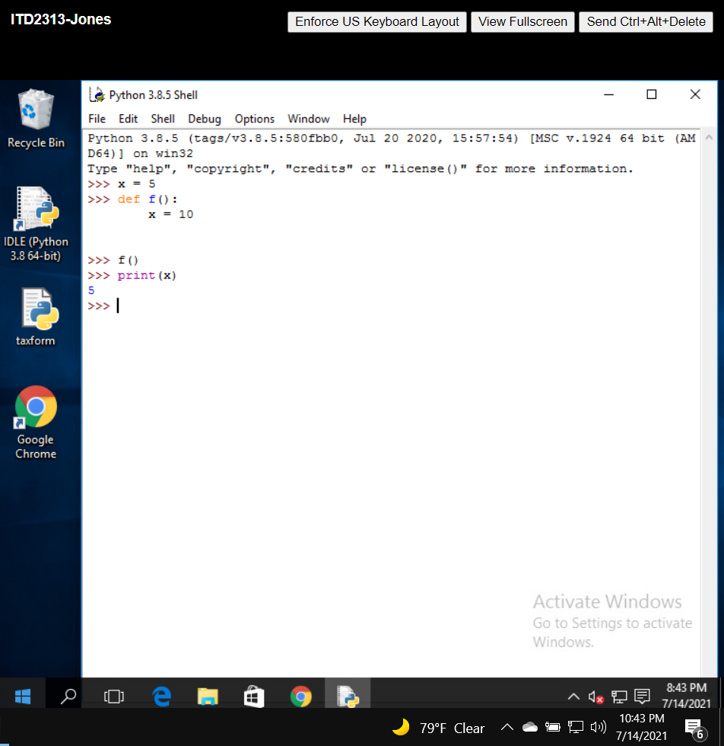

Page 194:

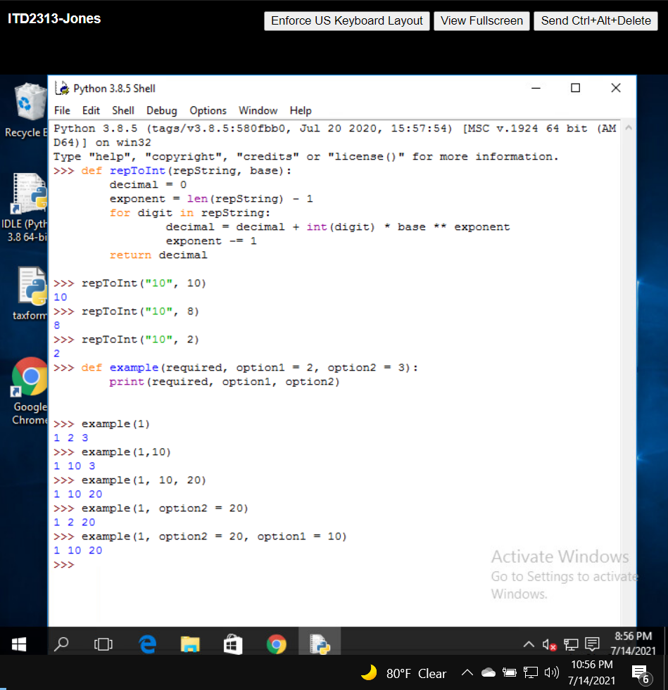

Page 195:

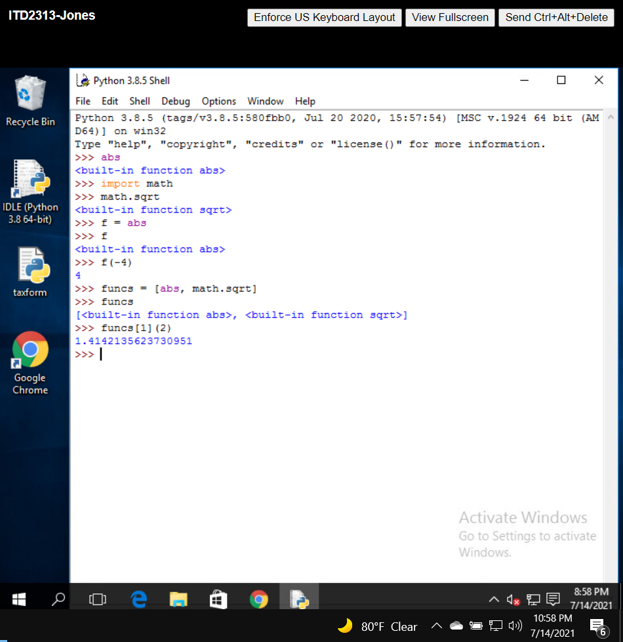

Page 196:

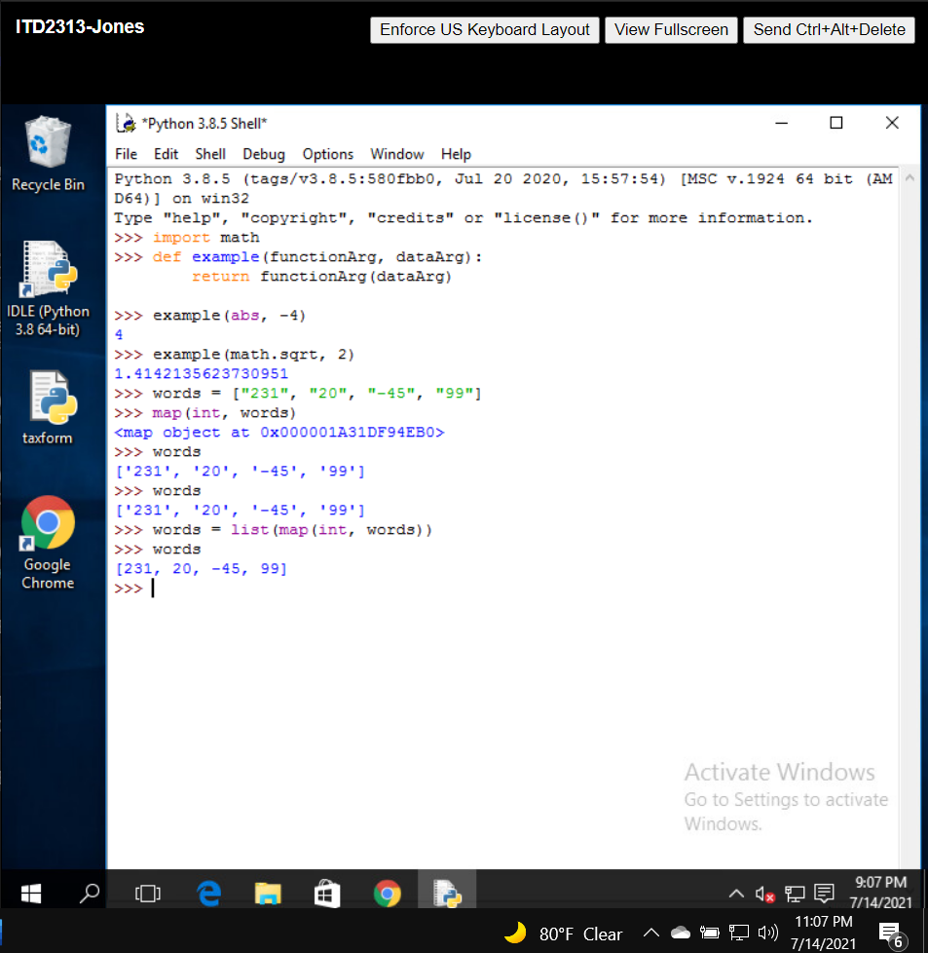

Page 197:

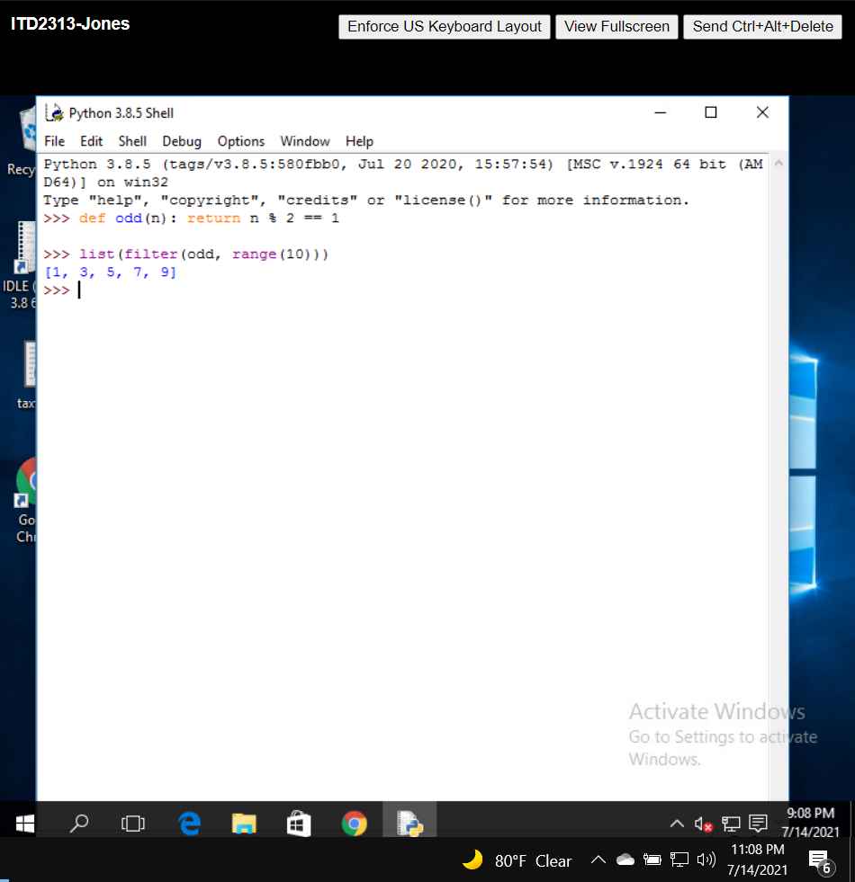

Page 198:

